**PROGRAM 3:**

**Working on worksheets:**

Worksheet in the Tableau screen is the area where you create the views for data analysis. By default, Tableau provides three blank worksheets when you have established a connection to data source. You can go on adding multiple worksheets to look at different data views in the same screen, one after another.

**1.Adding a Worksheet:**

We can add a worksheet in two ways. Right-click on the name of the current worksheet and choose the option New Worksheet from the pop-up menu. We can also click on the small icon to the right of the last sheet name to add a worksheet.

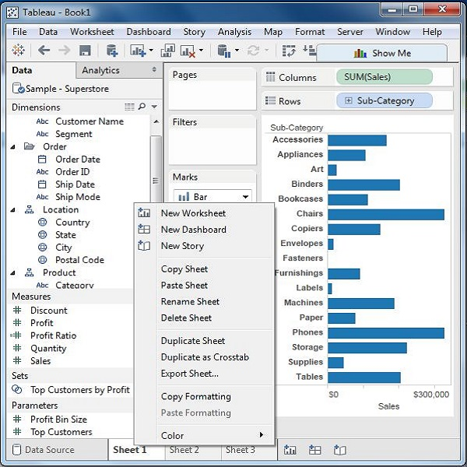

**2.Quick Preview of a Worksheet:**

Staying in one worksheet, you can have a quick preview of another worksheet by hovering the mouse on the name of the other worksheet.

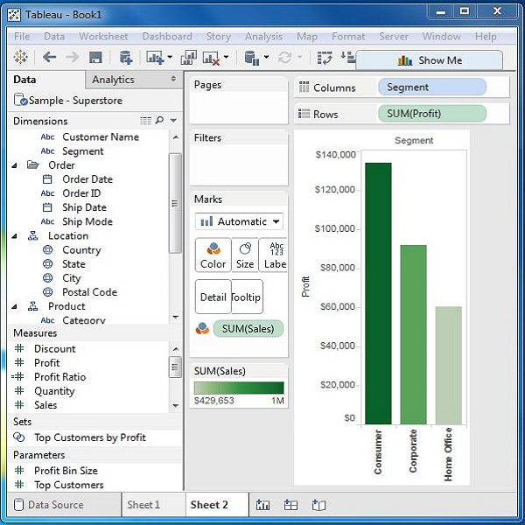

You can give appropriate names to the existing worksheets by renaming a worksheet. This helps in relating the content of the worksheet with its name. For example, if we want to know which sheet has the view to know the segment wise profit then with a proper name of the sheet we can identify it.

**3.Renaming the Worksheet:**

To rename a worksheet, right-click the sheet name and choose the option Rename Sheet.

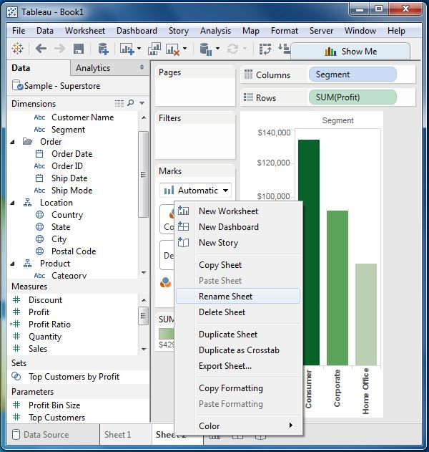

The following diagram shows the worksheet with the new name.

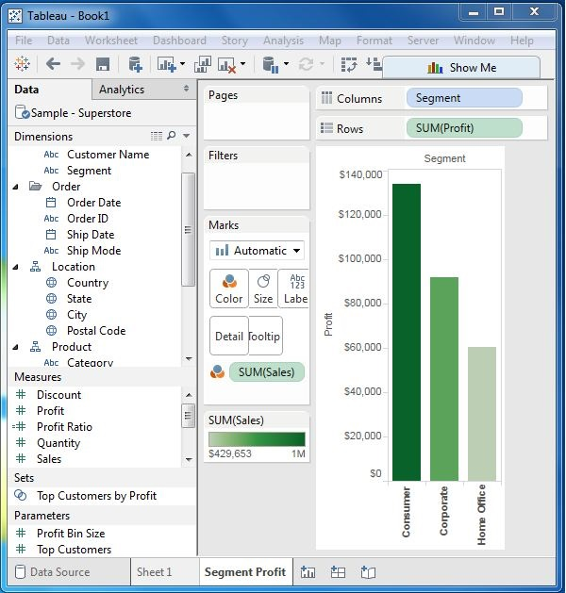

An existing worksheet can be both saved and deleted. This helps in organizing the contents in the Tableau desktop environment. While you can save a worksheet by clicking the save button under the main menu, you can delete a worksheet using the following steps.

**4.Deleting the Worksheet:**

To delete a worksheet, right-click on name of the worksheet and choose the option ‘Delete Sheet’.

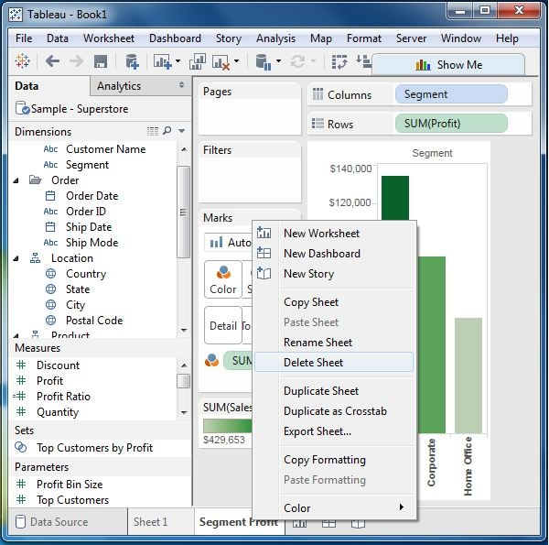

The following screenshot shows the worksheet has been deleted.

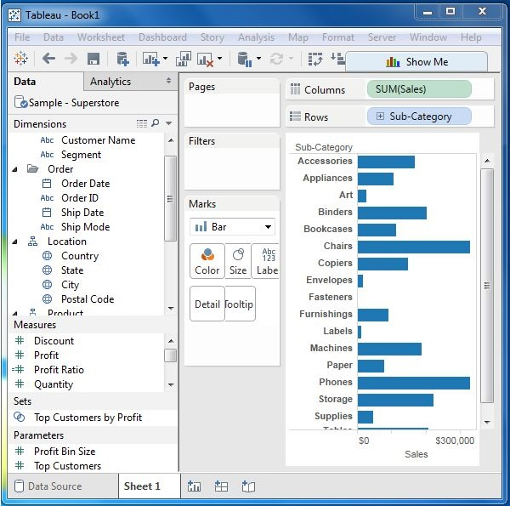

Sometimes you need to change the position of the existing worksheet to study them in a better way. This can be done in a simple way by dragging the sheet name from its existing position to the new position.

The following screenshot shows that a vertical dark line appears in the new position on dragging the third worksheet from left to the new position.

A paged workbook is used to save the view of the data in different pages for different values of the dimension or measure. A common example is to see how each type of products have performed against each other in a specific sales region. As each of the values of product type is stored as a separate page, we can view them one at a time or see it as a range of values.

**Creating Paged Workbook:**

The paged workbook contains worksheets which have fields put in the page shelf. Consider an example of studying the profit of various sub-category of products in different regions. Following are the steps.

**Step 1** − Create a bar chart with two dimensions and one measure. In this case, drag the Measure Profit to the columns shelf and the dimensions sub-category, and Region to the rows shelf as shown in the following screenshot.

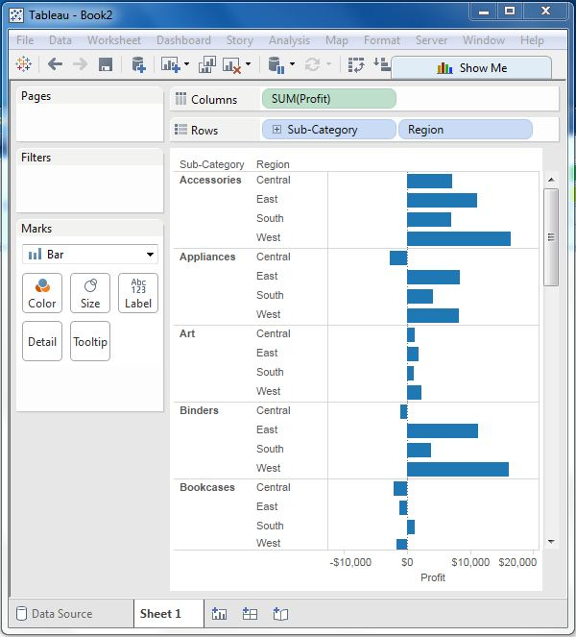

**Step 2** − Drag the Sub-Category field again to the page shelf. You will see that a page control is automatically added, just below the Pages shelf. This page control provides the following features to navigate through the pages in a view −

* Jump to a specific page
* Manually advance through the pages
* Automatically advance through pages

In this case, we will see how to jump to a specific page and how to get the automatic display of pages. To go to a specific page, click on the drop-down on the page control and select Accessories. The chart seen in the following screenshot appears.

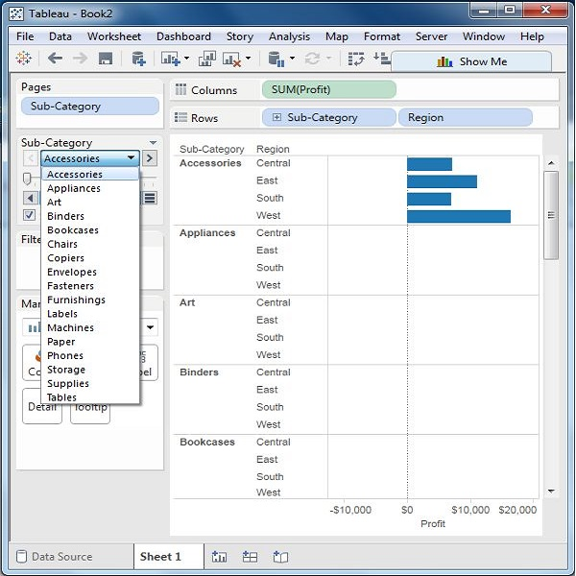

**Step 3** − For automatic display of pages, keep the show history checkbox ticked and click the play button. You can then see an automatic play of different pages of sub categories. While the current Sub-Category value is shown with a dark color, the previous values are shaded with light color. The following screenshot illustrates this.

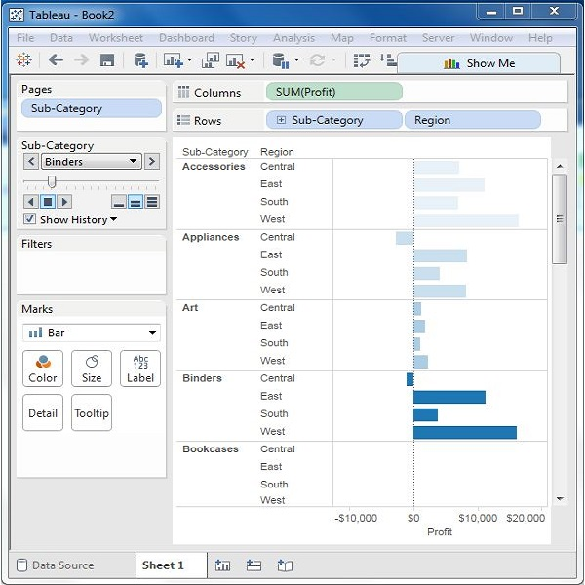

**PROGRAM 4**:

**AIM:- Applying the Calculations (Operators, Functions, Numerical Calculations, String, Date, Table).**

**Explanation:** An operator is a symbol that tells the compiler to perform specific mathematical or logical manipulations. Tableau has a number of operators used to create calculated fields and formulas.

Following are the details of the operators that are available and the order (precedence) of operations.

## Types of Operator:

* General Operators
* Arithmetic Operators
* Relational Operators
* Logical Operators

### General Operators:

Following table shows the general operators supported by Tableau. These operators act on numeric, character, and date data types.

|  |  |  |
| --- | --- | --- |
| **Operator** | **Description** | **Example** |
| **+(addition)** | Adds two numbers. Concatenates two strings. Adds days to dates. | 7 + 3  Profit + Sales  'abc' + 'def' = 'abcdef'  #April 15, 2004# + 15 = #April 30,  2004# |
| **–(subtraction)** | Subtracts two numbers. Subtracts days from dates. | -(7+3) = -10  #April 16, 2004# - 15 = #April 1,  2004# |

### Arithmetic Operators:

Following table shows the arithmetic operators supported by Tableau. These operators act only on numeric data types.

|  |  |  |
| --- | --- | --- |
| **Operator** | **Description** | **Example** |
| **\*(Multiplication)** | Numeric multiplication | 23*2 = 46 |
| **/(Division)** | Numeric division | 45/2 = 22.5 |
| **%(modulo)** | Reminder of numeric division | 13 % 2 = 1 |
| **^(power)** | Raised to the power | 2^3 = 8 |

### C Operators:

Following table lists the comparison operators supported by Tableau. These operators are used in expressions. Each operator compares two numbers, dates, or strings and returns a Boolean (TRUE or FALSE). Booleans themselves, however, cannot be compared using these operators.

|  |  |  |
| --- | --- | --- |
| **Operator** | **Description** | **Example** |
| **= = or = (Equal to)** | Compares two numbers or two strings or two dates to be equal. Returns the Boolean value TRUE if they are, else returns false. | ‘Hello’ = ‘Hello’ 5 = 15/ 3 |
| **!= or <> (Not equal to)** | Compares two numbers or two strings or two dates to be unequal. Returns the Boolean value TRUE if they are, else returns false. | ‘Good’ <> ‘Bad’ 18 != 37 / 2 |
| **> (Greater than)** | Compares two numbers or two strings or two dates where the first argument is greater than second. Returns the boolean value TRUE if it is the case, else returns false. | [Profit] > 20000 [Category] > ‘Q’ [Ship date] > #April 1, 2004# |
| **< (Less than)** | Compares two numbers or two strings or two dates where the first argument is smaller than second. Returns the boolean value TRUE if it is the case, else returns false. | [Profit] < 20000 [Category] < ‘Q’ [Ship date] < #April 1, 2004# |

### Logical Operators:

Following table shows the logical operators supported by Tableau. These operators are used in expressions whose result is a Boolean giving the output as TRUE or FALSE.

|  |  |  |
| --- | --- | --- |
| **Operator** | **Description** | **Example** |
| **AND** | If the expressions or Boolean values present on both sides of AND operator is evaluated to be TRUE, then the result is TRUE. Else the result is FALSE. | [Ship Date] > #April 1, 2012# AND [Profit] > 10000 |
| **OR** | If any one or both of the expressions or Boolean values present on both sides of AND operator is evaluated to be TRUE, then the result is TRUE. Else the result is FALSE. | [Ship Date] > #April 1, 2012# OR [Profit] > 10000 |
| **NOT** | This operator negates the Boolean value of the expression present after it. | NOT [Ship Date] > #April 1, 2012# |

### ercedence:

The following table describes the order in which operators are evaluated. The top row has the highest precedence. Operators on the same row have the same precedence. If two operators have the same precedence, they are evaluated from left to right in the formula. Also parentheses can be used. The inner parentheses are evaluated before the outer parentheses.

|  |  |
| --- | --- |
| **Precedence** | **Operator** |
| **1** | –(negate) |
| **2** | ^(power) |
| **3** | *, /, % |
| **4** | +, – |
| **5** | ==, >, <, >=, <=, != |
| **6** | NOT |
| **7** | AND |
| **8** | OR |

Any data analysis involves a lot of calculations. In Tableau, the calculation editor is used to apply calculations to the fields being analyzed. Tableau has a number of inbuilt functions which help in creating expressions for complex calculations.

Following are the description of different categories of functions.

* Number Functions
* String Functions
* Date Functions
* Logical Functions
* Aggregate Functions

## Number Functions:

These are the functions used for numeric calculations. They only take numbers as inputs. Following are some examples of important number functions.

|  |  |  |
| --- | --- | --- |
| **Function** | **Description** | **Example** |
| **CEILING (number)** | Rounds a number to the nearest integer of equal or greater value. | CEILING(2.145) = 3 |
| **POWER (number, power)** | Raises the number to the specified power. | POWER(5,3) = 125 |
| **ROUND (number, [decimals])** | Rounds the numbers to a specified number of digits. | ROUND(3.14152,2) = 3.14 |

## String Functions:

String Functions are used for string manipulation. Following are some important string functions with examples

|  |  |  |
| --- | --- | --- |
| **Function** | **Description** | **Example** |
| **LEN (string)** | Returns the length of the string. | LEN("Tableau") = 7 |
| **LTRIM (string)** | Returns the string with any leading spaces removed. | LTRIM(" Tableau ") = "Tableau" |
| **REPLACE (string, substring, replacement)** | Searches the string for substring and replaces it with a replacement. If the substring is not found, the string is not changed. | REPLACE("GreenBlueGreen", "Blue", "Red") = "GreenRedGreen" |
| **UPPER (string)** | Returns string, with all characters uppercase. | UPPER("Tableau") = "TABLEAU" |

## Date Functions:

Tableau has a variety of date functions to carry out calculations involving dates. All the date functions use the **date_part** which is a string indicating the part of the date such as - month, day, or year. Following table lists some examples of important date functions.

|  |  |  |
| --- | --- | --- |
| **Function** | **Description** | **Example** |
| **DATEADD (date_part, increment, date)** | Returns an increment added to the date. The type of increment is specified in **date_part**. | DATEADD ('month', 3, #2004-04-15#) = 2004-0715 12:00:00 AM |
| **DATENAME (date_part, date, [start_of_week])** | Returns **date_part** of date as a string. The **start_of_week** parameter is optional. | DATENAME('month', #200404-15#) = "April" |
| **DAY (date)** | Returns the day of the given date as an integer. | DAY(#2004-04-12#) = 12 |
| **NOW( )** | Returns the current date and time. | NOW( ) = 2004-04-15 1:08:21 PM |

## Logical Functions:

These functions evaluate some single value or the result of an expression and produce a boolean output.

|  |  |  |
| --- | --- | --- |
| **Function** | **Description** | **Example** |
| **IFNULL (expression1, expression2)** | The IFNULL function returns the first expression if the result is not null, and returns the second expression if it is null. | IFNULL([Sales], 0) = [Sales] |
| **ISDATE (string)** | The ISDATE function returns TRUE if the string argument can be converted to a date, and FALSE if it cannot. | ISDATE("11/05/98") = TRUE  ISDATE("14/05/98") = FALSE |
| **MIN(expression)** | The MIN function returns the minimum of an expression across all records or the minimum of two expressions for each record. |  |
|  |  |  |

## Aggregate Functions:

|  |  |  |
| --- | --- | --- |
| **Function** | **Description** | **Example** |
| **AVG(expression)** | Returns the average of all the values in the expression. AVG can be used with numeric fields only. Null values are ignored. |  |
| **COUNT (expression)** | Returns the number of items in a group. Null values are not counted. |  |
| **MEDIAN (expression)** | Returns the median of an expression across all records. Median can only be used with numeric fields. Null values are ignored. |  |
| **STDEV (expression)** | Returns the statistical standard deviation of all values in the given expression based on a sample of the population. |  |

1.**NUMERIC CALCULATIONS:**

Numeric calculations in Tableau are done using a wide range of inbuilt functions available in the formula editor.

Following are the steps to create a calculation field and use numeric functions in it.

**1.Create a calculated field:**

The example in this article uses the **Sample-Superstore** data source that comes with Tableau Desktop. To follow along with the steps in this article, connect to the **Sample-Superstore** saved data source and navigate to **Sheet 1**.

* In Tableau, select Analysis > Create Calculated Field.
* In the Calculation Editor that opens, do the following:
* Enter a name for the calculated field. In this example, the field is called, Discount Ratio.
* Enter a formula. This example uses the following formula:

IIF([Sales] !=0, [Discount]/[Sales],0)

* This formula checks if sales is not equal to zero. If true, it returns the discount ratio (Discount/Sales); if false, it returns zero.

|  |  |
| --- | --- |
| Tip: | To see a list of available functions, click the triangle icon on the right-side of  the Calculation Editor. |

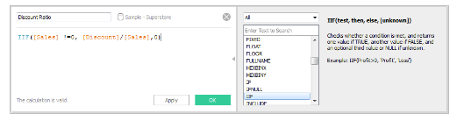

Each function includes syntax, a description, and an example for your reference.

* Double-click a function in the list to add it to the formula.
* When finished, click **OK**.

The new calculated field is added to Measures in the Data pane because it returns a number. An equal sign (=) appears next to the data type icon. All calculated fields have equal signs (=) next to them in the **Data** pane.

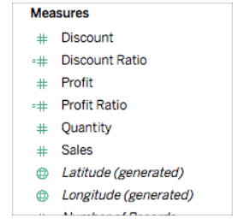

## 2.Use a calculated field in the view:

### Step 1: Build the view

1. From Dimensions, drag **Region**to the **Columns**shelf.
2. From Dimensions, drag **Category**to the **Rows**shelf.
3. On the **Rows**shelf, click the plus icon (**+**) on the **Category**field to drill-down to Subcategory.

The view updates to look like this:

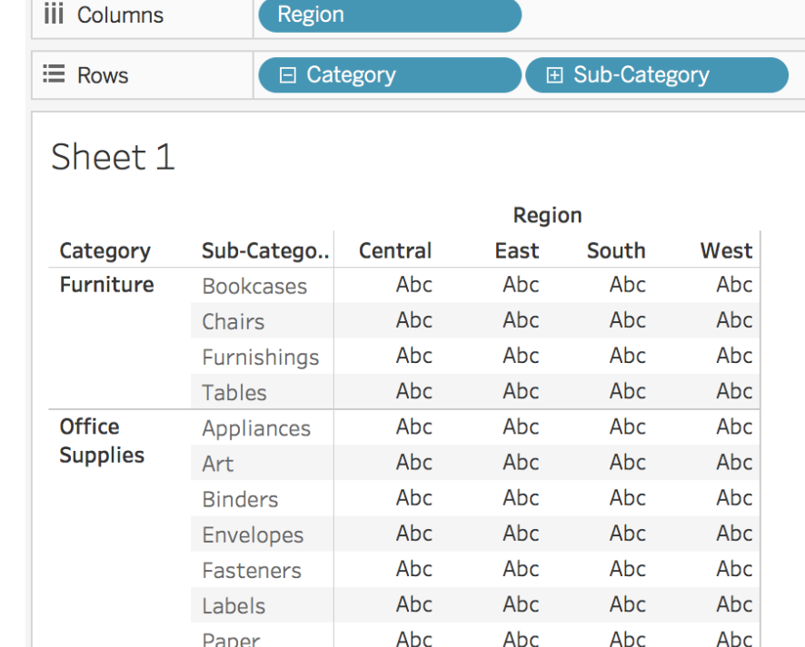

### 3. Add the calculated field to the view

1. From Measures, drag **Discount Ratio** to **Color**on the Marks card.

The view updates to highlight table.

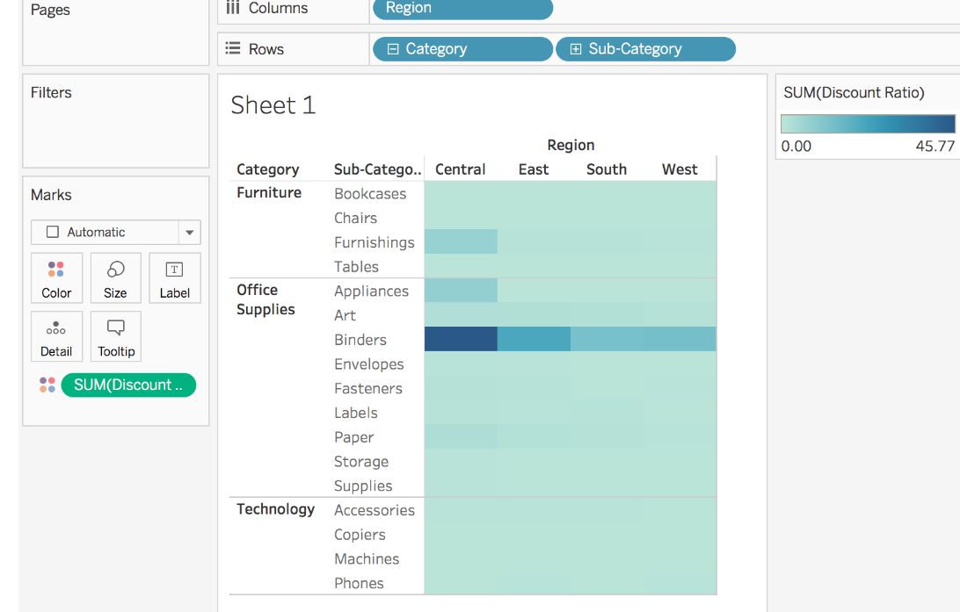

1. You can see that Binders are heavily discounted in the Central region. Notice that Discount Ratio is automatically aggregated as a sum.
2. On the Rows shelf, right-click **SUM(Discount Ratio)** and select **Measure (Sum)** > **Average**.

The view updates with the average of discount ratio shown.

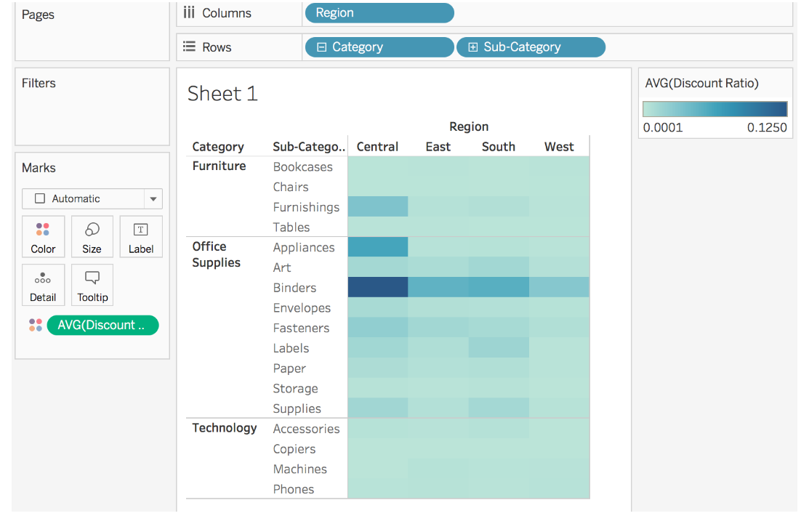

**4. To edit a calculated field:**

1. In the **Data** pane, right-click the calculated field and select **Edit**.
2. In the Calculation Editor that opens, you can do the following:
   * Edit the name of the calculated field.
   * Update the formula.

For this example, the formula is changed to return a discount ratio for orders over 2000 USD in sales:

IIF([Sales] > 2000, [Discount]/[Sales],0)

1. Click **OK**.

The view updates to reflect the changes automatically. You *do not* need to re-add the updated calculated field to the view.

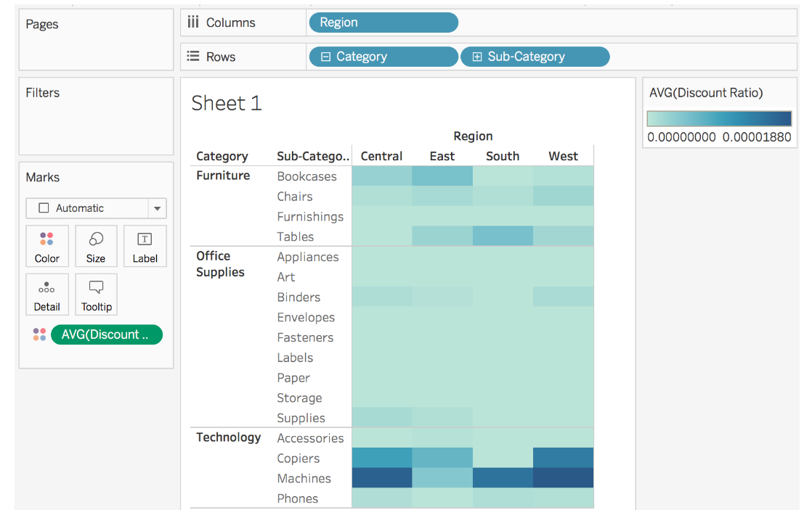

## A(i).Create Calculated Field:

While connected to Sample-superstore, go to the Analysis menu and click ‘Create Calculated Field’, as shown in the following screenshot.

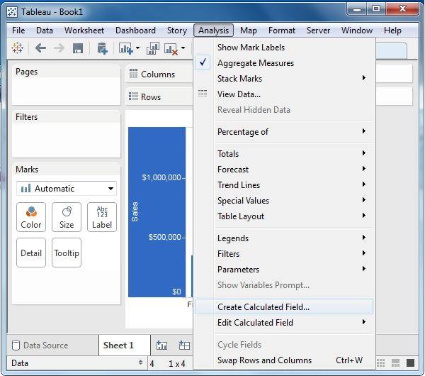

## A(ii).Calculation Editor:

The above step opens a calculation editor which lists all the functions that is available in Tableau. You can change the drop-down value and see only the functions related to numbers.

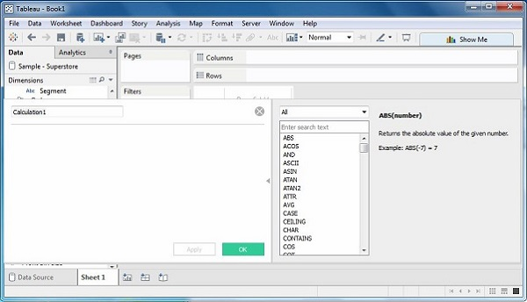

## A(iii).Create a Formula:

To study the difference between profit and discount for different shipping mode of the products, create a formula subtracting the discount from the profit as shown in the following screenshot. Also, name this field as **profit_n_discount**.

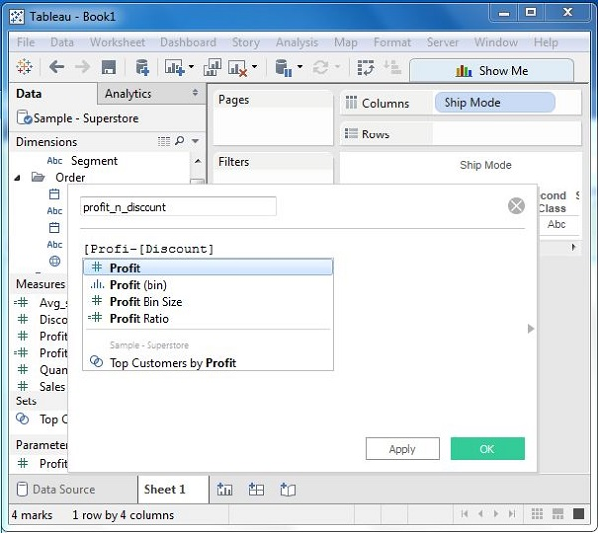

## A(iv).Using the Calculated Field:

The above calculated field can be used in the view by dragging it to the Rows shelf as shown in the following screenshot. It produces a bar chart showing the difference between profit and discount for different shipping modes.

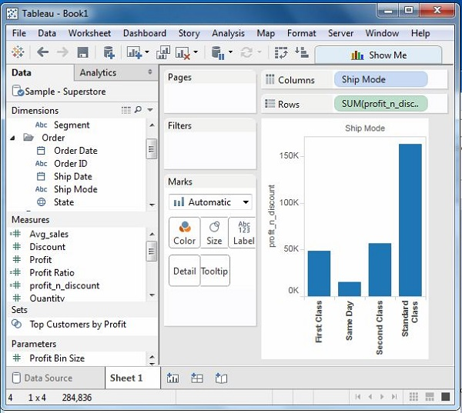

## Applying Aggregate Calculations

In a similar manner as above, you can create a calculated field using aggregate function. Here, create AVG(sales) values for different ship mode. Write the formula in the calculation editor as shown in the following screenshot.

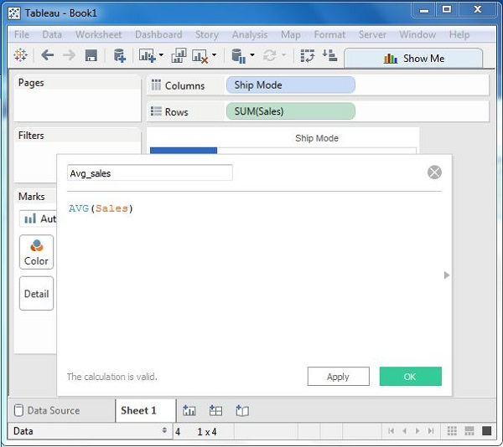

On clicking OK and dragging the Avg_Sales field to the Rows shelf, you will get the following view.

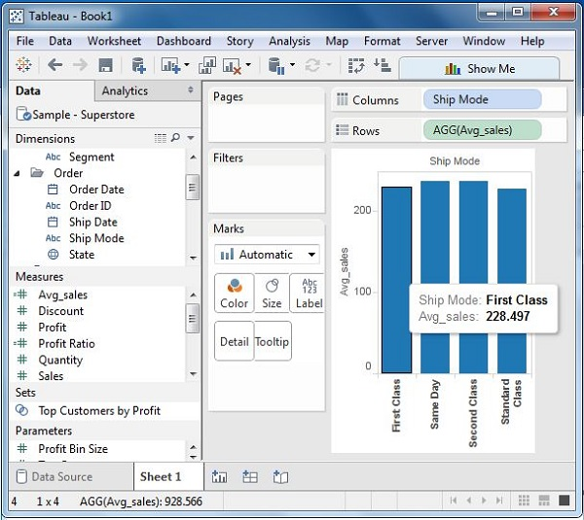

**Applying String Functions:**

Tableau has many inbuilt **string functions**, which can be used to do string manipulations such as - comparing, concatenating, replacing few characters from a string, etc. Following are the steps to create a calculation field and use string functions in it.

## 1.Create Calculated Field

While connected to Sample superstore, go to the Analysis menu and click ‘Create Calculated Field’ as shown in the following screenshot.



## 2.Calculation Editor

The above step opens a calculation editor which lists all the functions that is available in Tableau. You can change the dropdown value and see only the functions related to strings.

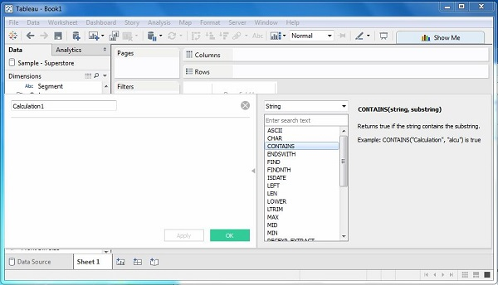

## 3.Create a Formula

Consider you want to find out the sales in the cities, which contain the letter “o”. For this, create the formula as shown in the following screenshot.

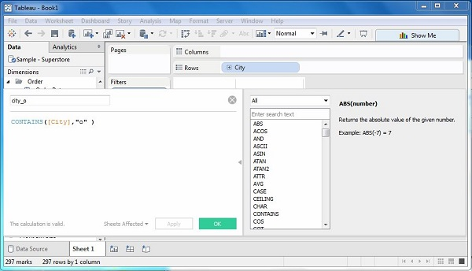

## 4.Using the Calculated Field

Now, to see the created field in action, you can drag it to the Rows shelf and drag the Sales field to the Columns shelf. The following screenshot shows the Sales values.

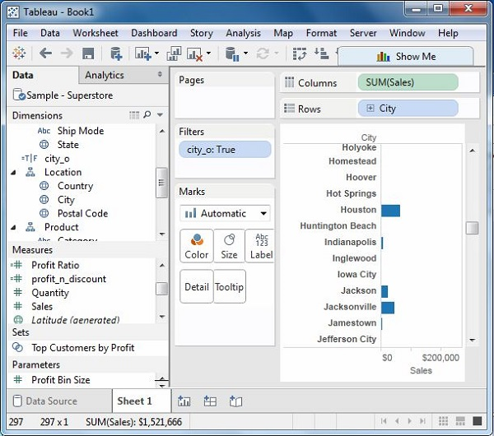

**Applying Date Functions:**

The steps to create a calculation field and use date functions in it.

## 1.Create Calculated Field

While connected to Sample superstore, go to the Analysis menu and click ‘Create Calculated Field’, as shown in the following screenshot.



## 2.Calculation Editor

The above step opens a calculation editor, which lists all the functions available in Tableau. You can change the dropdown value and see only the functions related to Date.

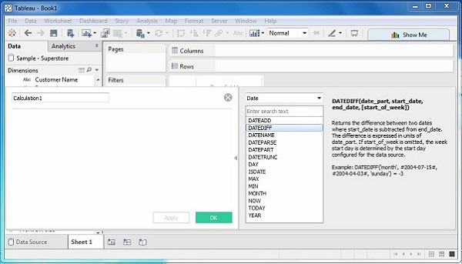

## 3.Create a Formula

Now, find out the sales volume along with the difference in the date of sales in months from 21st March 2009. For this, create the formula as shown in the following screenshot.

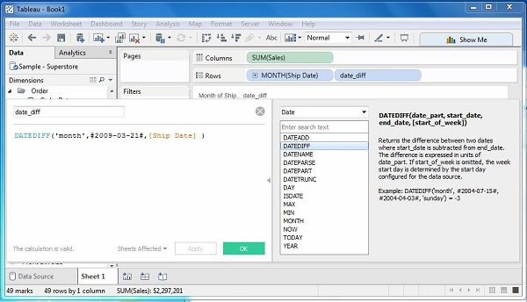

## 4.Using the Calculated Field

Now to see the created field in action, you can drag it to the Rows shelf and drag the Sales field to the Columns shelf. Also drag the ship Date with months. The following screenshot shows the Sales values.

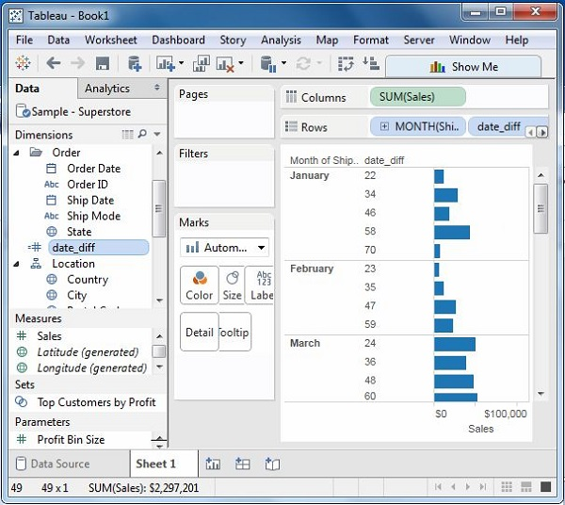

These are the calculations which are applied to the values in the entire table. For example, for calculating a running total or running average, we need to apply a single method of calculation to an entire column. Such calculations cannot be performed on some selected rows.

Table has a feature called **Quick Table Calculation**, which is used to create such calculations. The steps to be applied in Quick Table calculation are as follows −

**Step 1** − Select the measure on which the table calculation has to be applied and drag it to column shelf.

**Step 2** − Right-click the measure and choose the option Quick Table Calculation.

**Step 3** − Choose one of the following options to be applied on the measure.

* Running Total
* Difference
* Percent Difference
* Percent of Total
* Rank
* Percentile
* Moving Average
* Year to Date (YTD) Total
* Compound Growth Rate
* Year over Year Growth
* Year to Date (YTD) Growth